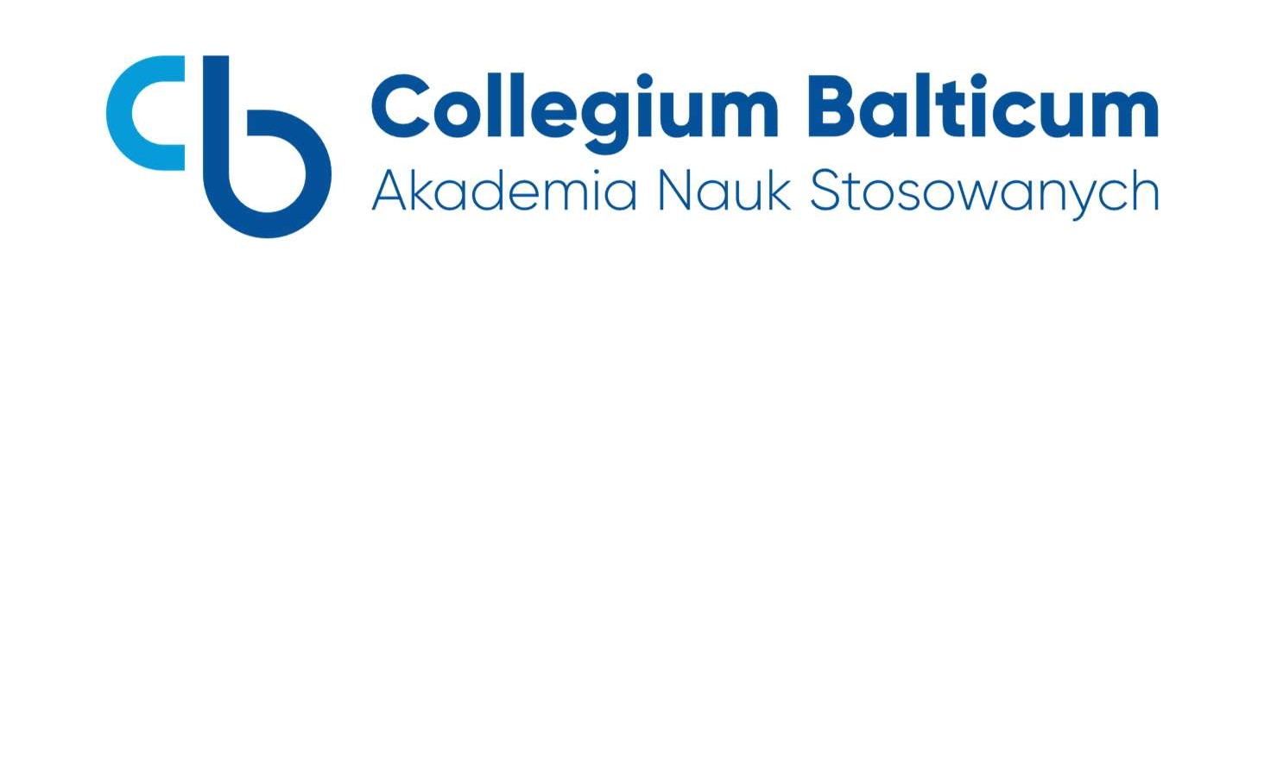

**APPLICATION FORM FOR POSTGRADUATE STUDIES**

……………………………………………………………………………………………………………………………

…………………………………………………………………………………………….………………………………

(name of the course)

**PLEASE FILL IN BY COMPUTER OR IN CAPITAL LETTERS**

|  |  |
| --- | --- |
| ***Name and Surname*** |  |
| ***Date and place of birth / country*** |  |
| ***Personal ID number*** |  |
| ***Residential address*** |  |
| ***Correspondence address*** |  |
| ***Phone number*** |  |
| ***E-mail address*** |  |
| ***Graduated college and year of completion*** |  |
| ***Field of study and specialization, professional title, diploma number*** |  |
| ***Place of work,***  ***with exact address, phone number*** |  |
| ***Occupation performed*** |  |
| ***I declare that: select the appropriate*/*** | ***I do not have pedagogical training*/***  ***I have pedagogical training for the subject /classes taught ………………………………………………………..……………..*** |

*I enclose the following documents with my application:*

*• A copy of my higher education diploma, parts A and B (original available for inspection)*

*• My ID card available for inspection*

**APPLICATION FORM FOR POSTGRADUATE STUDIES**

**Declaration**

We inform you that the Administrator (the entity determining the purposes and methods of personal data processing) is **Collegium Balticum - Academy of Applied Sciences with its registered office in Szczecin, ul. Mieszka I 61C, 70-011 Szczecin, NIP 955-197-85-51**, e-mail address: podyplomowe@cb.szczecin.pl

Your personal data may be processed for the purposes carried out by the Administrator based on various legal grounds. Below we outline the purposes and premises legalizing the processing of your personal data, in particular:

1. sending marketing information about services and products to the e-mail address or phone number indicated by you, to the e-mail address indicated by you - pursuant to art. 6 sec. 1 letter f) of the GDPR - the legitimate interest of the Administrator in the form of direct marketing of its own products and services, and to use your communication channels (phone number, e-mail address) to send marketing information, we need consent in accordance with art. 172 of the Act of 16 July 2004 - Telecommunications Law and art. 10 of the Act of 18 July 2002 on the provision of services by electronic means. The data will be processed until the consent is withdrawn or an effective objection is filed regarding the processing of personal data;
2. enabling contact with the Administrator via personal data left in the contact form - to pursue our legitimate interest in ensuring communication with the website user and responding to inquiries addressed to Collegium Balticum - Academy of Applied Sciences with its registered office in Szczecin - on the basis of art. 6 sec. 1 letter f) of the GDPR and art. 352 sec. 14 and 15 of the Act of 20 July 2018 - Law on Higher Education and Science.

Personal data will be stored:

1. in the case of personal data processed on the basis of consent - until the withdrawal of the consent, without affecting the legality of processing prior to its expression;
2. in the case of providing an answer to a question via the contact form - until the question is answered or until an effective objection to the processing of personal data is raised;
3. for marketing purposes - until an objection to the processing of data is raised or the consent to processing is withdrawn;
4. in the case of proceedings conducted by authorized bodies, the deadline for deletion of data may be extended until its final conclusion.

In connection with the processing of your personal data by the Administrator, you have the following rights:

1. access to your personal data and receive a copy thereof;

2. request the restriction of processing or rectification of personal data;

3. request the deletion of personal data;

4. object to the processing of personal data;

5. withdraw consent to the processing of personal data at any time, without affecting the lawfulness of processing based on the consent given before its withdrawal;

6. lodge a complaint in connection with the processing of personal data with the supervisory authority – the President of the Personal Data Protection Office.

The Administrator informs that each time you exercise your rights, the Administrator will assess and verify the request.

The recipients of personal data may be entities providing and supporting the Administrator's IT systems and other entities cooperating with the Administrator, under appropriate personal data processing agreements and ensuring that the above entities apply adequate technical and organizational measures to ensure data protection. Personal data may also, in some cases, be transferred to entities authorized to obtain them under applicable law.

The recipients of the data may have their registered office in a country outside the European Economic Area (EEA), however, in this case the Administrator will take care of all formalities related to the proper protection of personal data, including, among others, the use of standard contractual clauses adopted by the Commission (EU).

Your data is not subject to automated decision-making, including profiling. Providing personal data by you is voluntary.

[ ]

I hereby voluntarily consent, pursuant to Article 172 of the Act of 16 July 2004 - Telecommunications Law and Article 10 of the Act of 18 July 2002 on the provision of services by electronic means, to receive marketing and information materials (in particular the educational offer) from Collegium Balticum - Academy of Applied Sciences with its registered office in Szczecin, via the following means of communication indicated in the form:

[ ] telephone

[ ] sms

[ ] e-mail address